


Committee on Committees Minutes

Associated Students
DATE: January 12th, 2026
LOCATION: UCEN Flying A Room Minutes/Actions recorded by: Shuyi Sum

CALL TO ORDER: 6:53pm by Lily Strange, Internal Chair

QOTW: What is one skill or experience you hope to gain through CoC this winter quarter to support your goals at UCSB and beyond?

A. MEETING BUSINESS

- Roll Call

Name | Note:  absent (excused/not excused)  arrived late (time)  departed early (time)  proxy (full name) | Name | Note:  absent (excused/not excused)  arrived late (time)  departed early (time)  proxy (full name)
Sophia Fei | Present | Yeshua Valdez Rodriguez | Excused
Lily Strange | Present | Savanah Lizet Aldaba | Present
Shuyi Sum | Present | Adam Orenstein | ...
Oliver Ramirez Carrera | Excused | Rylee Bones | Present
Layla Hakim | Present | Archish Prakhya | Present
Mira Ikladious | Present

- Acceptance of Excused Absences

MOTION/SECOND: Lily/Shuyi
Motion Language: I motion to excuse Yeshua and Oliver from tonight’s meeting.
ACTION: Consent

- Acceptance of Proxies

B. PUBLIC FORUM

- EXTERNAL REPORTS

- Advisor’s Report

- Executive Officer’s Report(s)

- Group Project/Member Report(s)
  - Advisor and Senate Liaison Reports

Lily Strange - Internal Chair
    - QOTW: networking! I think practicing networking in AS is a lot more chill, since everyone is a student vs jumping right into networking with real adults.
    - Chairs meeting notes:
    - New GC! We are giving this one more go and then resorting to slack or groupme. Sophia can you add everyone to a chat and we can test it?
    - Hiring updates:
      - Website …???
        - The AS positions tab disappeared and we got two applications for things that are not open
        - I emailed the two applicants and offered them an interview for the pro temp and OSA positions if they want them
      - OSA form
      - Outreach is not hiring,
      - IG post + mailing list announcements
    - To publicize:
      - OSA → google form
      - TBTN and PMHC openings, details in our open positions spreadsheet
      - Second president pro temp…
    - Event planning for the year
      - O&R, let’s do 2 events this quarter:
      - Ideas from our budget proposal, we can change or add more:
        - Committees Cafe → coffee hour with tabling orgs that are hiring
          - Mira & rylee
        - Valentines themed matchmaking event, but students complete a career quiz to find their committee fit
        - Dinner with the chairs, learn about AS orgs that are hiring with free dinner
        - Vision boards, how AS can fit into your career goals
          - Layla, Savanah
        - AS job fair / recruitment fair (spring quarter, but we can start planning now if this would be a bigger event)
          - In general, we want to plan on having a big event spring quarter to use budget
      - Maybe work in teams of 2?
    - Honoraria reviews
    - Chairs meeting closing email / wrap up
      - Oliver, you can send this out sometime this week, no rush
    - Merch and logos! We can work with CMU to design cute stickers, tote bags, a new logo, etc. Is anyone interested in taking this project on? You will have to communicate with graphic designers in CMU, we can discuss ideas as a committee of designs, etc
      - COSWB worked with them for designs and they also coordinated ordering materials which we paid for with Gateway (not out of pocket)
      - We can do a tablecloth, stickers, tote bags, etc with this
    - We need to pass $631.29 for chipotle catering
      - Sophia, we also need to pass $$ for you
      - Who is an authorized signer?
    - Reminder: no involvement fair tomorrow
    - Everyone fill out this when2meet!
      - We need more responses
    - Keycards
    - 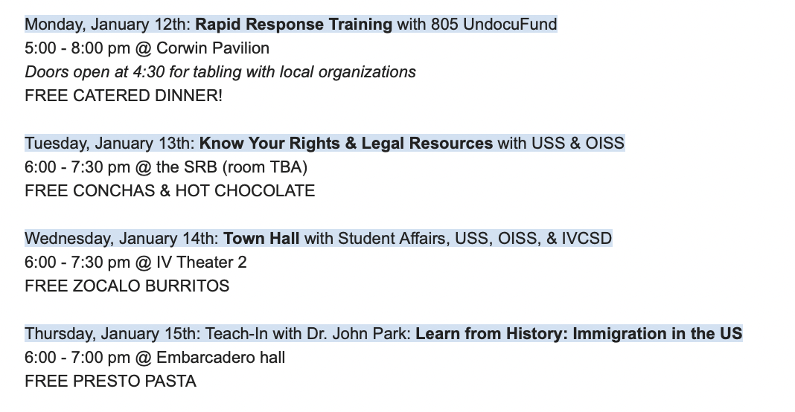
      - Protect Your Peers events! RSVP here

Sophia Fei - External Chair
    - QOTW: practicing keeping up and following through with projects and events
    - Honoraria feedback
    - Pearman fellows!!
    - Chairs meeting - requisitions - shuyi is authorized i believe
      - 👍 - Shuyi
      - Pass ~ $120 for reimbursement
    - Will become authorized
      - Savanah’s requisition can be signed rn
    - Publicize current events - protect your peers
    - Retreat event
    - Make groupchat for coc… AGAIN

Shuyi Sum - Vice Chair
    - QOTW: networking !! meeting ppl that I can keep in touch with outside of/after UCSB
    - Officially welcoming our Pearman Fellows !!!!
    - Quarterly Chairs Meeting RSVP (Responses)
→ W26 Attendance Tracking - 44+ attendees
    - Tabling w Le Anh - signups
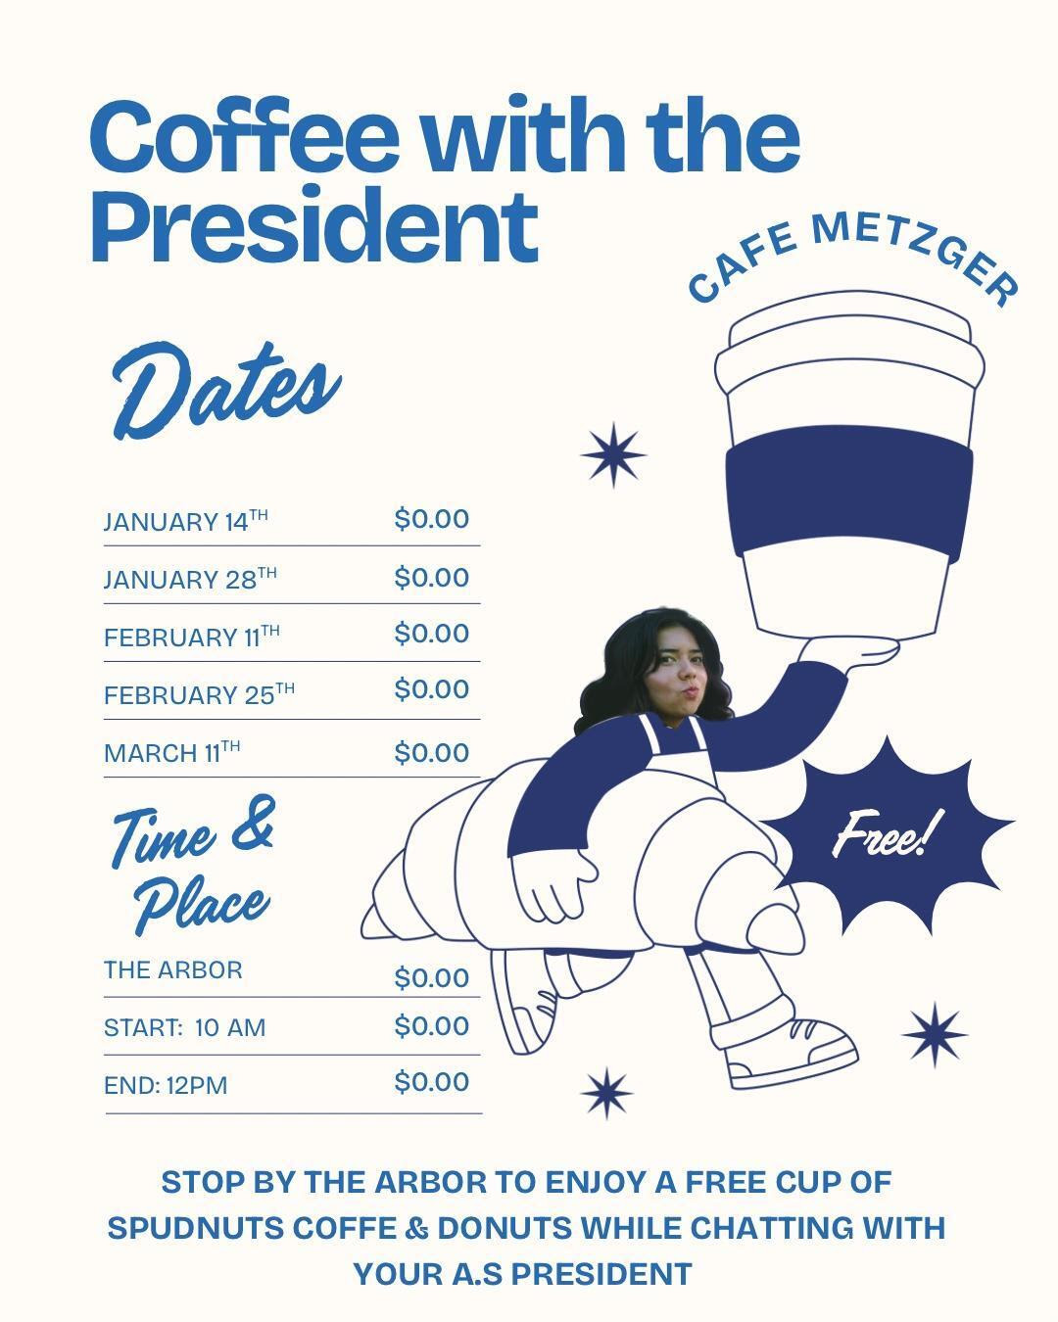
- WEDNESDAYS 10AM-12PM
- 1/14: 11am-12pm - Lily
- 1/28: 11am- 12pm- Savanah
- 2/11:
- 2/25:
- 3/11:

v. I’ll send out a When2Meet for interviews next week !!

Oliver Ramirez Carrera - Internal Liaison

VACANT - Internal Liaison

Layla Hakim - Outreach and Recruitment Coordinators
    - QOTW: definitely networking and public speaking!
    - Not too much to report, I can work on more emailing and/or IG posts
    - Chairs meeting, I’ll take notes!
    - Definitely want to work on more merch/brainstorming more ways of promoting
    - Had some issues with the (book bank) mass email, I received an error message and by the time they got back to me it was during the break. Will continue to try to figure it out within this/next week
    - Chairs meeting notes: https://docs.google.com/document/d/1Hz3jr4Cp43ur6ly-E8ZaDLz5MtaAnI1DK9DybwQbwoM/edit?tab=t.0
    - ***Repost / collab w coffee w president IG post
    - Definitely hiring: OSA, public and mental health commission, take back the night, office of senate leadership
    - ***Text Mira about keycards
    - ***Make new fliers for the updated open positions!

Mira Ikladious - Outreach and Recruitment Coordinators
  - Hopefully networking and getting more involved in promoting clubs through CoC/AS events, ect.
  - Not much from week 1,, Lily I was wondering abt the position info I should post abt on instagram (office of the student advocate) TBTN & Public mental health commission, 2nd prez protempt office of senate leadership maybe put down email
  - Chairs meeting,, set up & clean up
  - I would like to work on publicizing the protect your peers & first aid events (seen in pre-med & pre-law listserv but can also post abt)
  - O&R events collab
  - Key cards

Yeshua Valdez Rodriguez - Outreach and Recruitment Coordinators

Savanah Lizet Aldaba - Outreach and Recruitment Coordinators
    - QOTW: Through CoC I hope to gain more confidence with public speaking and organizing meaningful events.
    - Helped shop and set up for chairs meeting
    - Will be doing my first reimbursement process for the chipotle
    - Coffee with the President 1/28
    - Key Card??

Adam Orenstein - Commissioner of Community and Climate

Archish Prakhya - Pearman Fellow
    - QOTW: Through CoC this winter, I’m hoping to gain more confidence in navigating opportunities. I’m excited to use CoC to learn from mentors, hear different perspectives, and better understand what actually fits me.
    - Hi I’m Archish! I’m a sophomore majoring in Statistics and Data Science. I’m interested in research, problem solving, and work that creates tangible impact. I’m excited to learn from everyone in CoC this quarter and be part of the community!

Rylee Bones - Pearman Fellow
    - QOTW: During the winter quarter I am hoping to gain more skills in reaching out and expanding my professional circle. Networking is something I don’t have much experience with and I think CoC will help me start my journey to get a good group of people to work with and gain opportunities with.
    - Hi everyone, my name is Rylee and I’m a first year student majoring in political science. I’m really interested in learning how to work in groups and learn more about our student government. Can’t wait to meet everyone!
    - Schedule coffee w Pres tabling

C. Action Items

- ACCEPTANCE of AGENDA/CHANGES to AGENDA

- CONSENT ITEMS

- Approval of our Action Summary/Minutes from:

- ACTION ITEMS

F-1. Old Business:

F-2 New Business:

- DISCUSSION ITEMS

- Discussion Topic

- REMARKS

- ADJOURNMENT

MOTION/SECOND: Layla/Savanah
Motion Language: I motion to pass $631.29 for the Winter Quarter Chairs meeting Chipotle catering.
ACTION: CONSENT

MOTION/SECOND: Mira/Layla
Motion Language: I motion to pass $33.88 for the Winter Quarter Chairs meeting Chipotle catering (special allergy orders).
ACTION: CONSENT

MOTION/SECOND: Savanah/Mira
Motion Language: I motion to pass $130 for the Winter Quarter Chairs meeting snacks, drinks, utensils, and supplies from Costco and Target.
ACTION: CONSENT

MOTION/SECOND: Sophia/Shuyi
Motion Language: I motion to adjourn this meeting at 7:32pm.
ACTION: CONSENT

